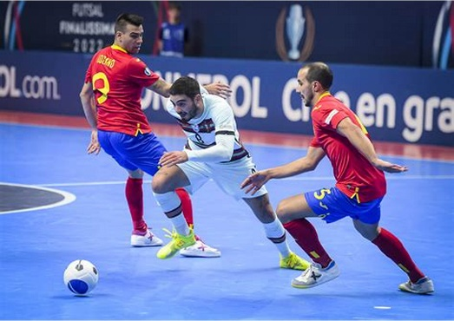**BISHS CREST: Futsal Sport Program 2026**

**Application Form**

Your student is invited to apply for the BISHS CREST: Futsal Sport Program.

**What is the CREST Futsal Sport Program?**

The BISHS CREST: Futsal Sport program is an all-inclusive program for students in that caters for individual needs for both males and females with the aim to create active, well rounded and committed young people with an interest in Futsal or Soccer.

The program provides students with the opportunity develop their skills and provide a genuine learning pathway with Futsal and Soccer as the lens for their studies.

Students in the program will gain access to a high-quality sporting program with recognised accredited Futsal and Soccer sport-based coaches and teachers. Student’s will participate in a tailored curriculum and engage in extracurricular Futsal excursions and activities.

**The program focuses on a holistic approach to talent development which is made up of 4 core areas:**

1. **Athlete Development:** Enhancement of fundamental skills, game knowledge and performance habits.
2. **Promoting personal Growth:** Through the development of leadership skills, wellbeing, communication and teamwork.
3. **Community:** Increased participation in the Pine River/North Brisbane Futsal Communities, whether it’s on the field as a player, or referee, or off the field as a coach.
4. **Future Pathways:** Students will be provided with a range of career pathways through the practical experience in Futsal related areas such sports performance, sports psychology and nutrition along with the opportunity to gain qualifications in areas such as coaching and umpiring. The Futsal program will have direct alignment to senior pathways in the senior phase of learning including Certificate III in Fitness, Certificate II in Sports and Recreation and Senior Physical Education

**Extra-Curricular Experiences:**

Students will be engaged in a number of experiences that will help develop the student around our core aims of the program. The possible experiences that the students will have the opportunity to participate in are:

* Potential Participation in some of the following competitions:

QLD Winter Titles

SEQ Futsal Challenge

Summer State Titles

* Mentoring by highly qualified coaches supported by the Australian Futsal Association
* Leadership development and team building days and activities
* Tailored Strength and conditioning programs and sessions
* Refereeing and coaching qualifications

**Expectations:**

Before committing to the CREST: Futsal sport program, it is important that you review the code of conduct with your child to fully understand and be aware of the commitments required to be a successful Futsal Excellence student.

Students should demonstrate:

1. Commitment to sporting pursuits and willingness to work within a team environment
2. A desire and ability to play Futsal or Soccer
3. School attendance is at 90% and provide explanations for any absences
4. Abide by the school’s behaviour expectations
5. Wear the School Uniform in correct manner at all times
6. Students are expected to participate in all school Futsal or Soccer games.
7. Demonstrate sportsmanship and fair play at all times
8. All students will be required to sign an agreement and pay annual fee (TBD) which includes; additional training gear, bus levies and the cost of extra-curricular activities. Any additional camps or excursions will incur additional costs

**Selection and Application for the Program**

* All students interested in applying for the Futsal sports program for 2026 must submit an **application form** either

A) by Microsoft forms link- <https://forms.office.com/r/Bt7Z9Q7LSm>

B) By hard copy application below and return emailed to emailed to [jjjef0@eq.edu.au](mailto:jjjef0@eq.edu.au) or submitted to BISHS administration building.

For further information of enquiries, please contact Jayden Jeffery at jjjef0eq.edu.au or call Bribie Island State High School on 3400 2444.

Kind regards,

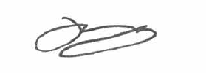

Mr Matthew Bradley Mr Jayden Jeffery

**Principal Head of Department- Junior Secondary**

|  |  |  |  |  |  |
| --- | --- | --- | --- | --- | --- |
| **BISHS CREST FUTSAL SPORTS- Application Form** | | | |  | |
|  |  | **STUDENT DETAILS** | |  | |
| STUDENT NAME |  |  | | | |
| DATE OF BIRTH |  |  | GENDER |  |  |
| ADDRESS |  |  | |  | |
| YEAR LEVEL APPLYING FOR IN 2026 (please circle) | Year 7 |  | Year 8 |  | |

|  |  |  |  |
| --- | --- | --- | --- |
|  | **PARENT DETAILS** | | |
| PARENT 1 |  | PARENT 2 | |
| FULL NAME |  | FULL NAME |  |
| PHONE NUMBER |  | PHONE NUMBER |  |
| EMAIL |  | EMAIL |  |
| ADDRESS (if different from student) |  | ADDRESS (if different from student) |  |

**BISHS CREST FUTSAL – Application Form**

1. **Why would you like to be involved in the Futsal program at Bribie Island State High School?**

1. **Are you currently involved in your school sporting community? If so, what sports do you play or how are you involved?**
2. **How are you currently involved in the sports community outside of school? If so, what club/ sports do you play.**
3. **What is your current level of experience playing Futsal or Soccer (playing history, club/school/representative)**