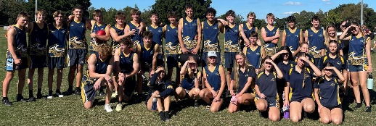**BISHS CREST: AFL Program 2025**

**Application Form**

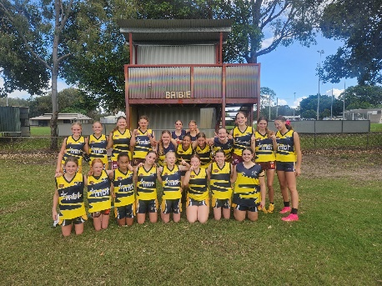Your student is invited to apply for the BISHS CREST: AFL Program.

**What is the CREST AFL Program?**

The BISHS CREST: AFL program is an all-inclusive program that caters for individual needs for both males and females with the aim to create active, well rounded and committed young people with an interest in AFL. The program provides students in Years 7-9 with the opportunity to develop their skills and provide a genuine learning pathway with AFL as the lens for their studies.

Students in the program will gain access to a high-quality sporting program with recognised accredited AFL coaches and teachers. Student’s will complete all elective subjects together for the academic year, as well as a tailored HPE curriculum and engage in extra curriculum AFL excursions and activities.

The program not only develops strong sporting and physical competence, it also offers a comprehensive education in leadership, communication and team building skills

**The program focuses on a holistic approach to talent development which is made up of 4 core areas:**

1. **Athlete Development:** Enhancement of fundamental skills, game knowledge and performance habits.
2. **Promoting personal Growth:** Through the development of leadership skills, wellbeing, communication and teamwork.
3. **Community:** Increased participation in the Bribie Island and Moreton Bay AFL Communities, whether it’s on the field as a player, or umpire, or off the field as a coach or volunteer at the local AFC club.
4. **Future Pathways:** Students will be provided with a range of career pathways through the practical experience in AFL and related areas such sports performance, sports psychology and nutrition along with the opportunity to gain qualifications in areas such as coaching and umpiring. The AFL program will have direct alignment to senior pathways in the senior phase of learning including Certificate III in Fitness, Certificate II in Sports and Recreation and Senior Physical Education

**Extra-Curricular Experiences:**

Students will be engaged in a number of experiences from grade 7 to 9 that will help develop the student around our core aims of the program. The possible experiences that the students will have the opportunity to participate in are:

* Participation in competitions such as the AFLQ schools of Excellence Cup and Gala Days
* Mentoring by highly qualified coaches supported by AFLQ
* Access to Professional AFL Education Programs including (Training Habits, Sports

Psychology, Nutrition, recovery)

* Leadership development and team building days and activities
* Tailored Strength and conditioning programs and sessions
* Umpiring and coaching qualifications

**Expectations:**

Before committing to the CREST: AFL Program, it is important that you review the code of conduct with your child to fully understand and be aware of the commitments required to be a successful AFL Excellence student.

Students should demonstrate:

1. Commitment to sporting pursuits and willingness to work within a team environment
2. A desire and ability to play AFL
3. School attendance is at 90% and provide explanations for any absences
4. Abide by the school’s behaviour expectations
5. Wear the School Uniform in correct manner at all times.
6. Students are expected to participate in all school AFL games
7. Demonstrate sportsmanship and fair play at all times.
8. All students will be required to sign an agreement and pay annual fee (TBD) which includes; additional training gear, bus levies and the cost of extra-curricular activities. Any additional camps or excursions will incur additional costs.

**Selection and Application for the Program**

* All students interested in applying for the AFL excellence program for 2025 must submit an **Expression of Interest form** located on the school website by Term 3 Week 5- Tuesday 6th of August 2024.

Please submit Expression of interest form by emailing complete form to [jjjef0@eq.edu.au](mailto:jjjef0@eq.edu.au)

* All Year 6 students applying for the program are required to attend a **Trial Day on** Term 3 Week 5- Wednesday 7th of August 2024. You can register by the following link:
* All students will be asked to place in a subsequent CREST: AFL Application form after the Expression of Interest window closes.

For further information of enquiries, please contact Jayden Jeffery at jjjef0eq.edu.au or call Bribie Island State High School on 3400 2444.

Kind regards,

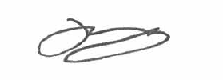

Mr Matthew Bradley Mr Jayden Jeffery

**Principal Head of Department- Junior Secondar**

|  |  |  |  |  |  |
| --- | --- | --- | --- | --- | --- |
| **APPLICATION FORM** |  |  | |  | |
|  |  | **STUDENT DETAILS** | |  | |
| STUDENT NAME |  |  | | | |
| DATE OF BIRTH |  |  | GENDER |  |  |
| ADDRESS |  |  | |  | |
| YEAR LEVEL APPLYING FOR IN 2025 (please circle) | Year 7 |  | Year 8 |  | Year 9 |
| PREVIOUS SCHOOL |  |  | |  | |

|  |  |  |  |
| --- | --- | --- | --- |
|  | **PARENT DETAILS** | | |
| PARENT 1 |  | PARENT 2 | |
| FULL NAME |  | FULL NAME |  |
| PHONE NUMBER |  | PHONE NUMBER |  |
| EMAIL |  | EMAIL |  |
| ADDRESS (if different from student) |  | ADDRESS (if different from student) |  |

**Personal Statement**

1. **Why would you like to be involved in the AFL program at Bribie Island State High School?**

1. **Are you currently involved in your school sporting community? If so what sports do you play or how are you involved?**
2. **How are you currently involved in the sports community outside of school? If so, what club/ sports do you play.**
3. **Have you had any leadership roles in school/ club/ community (e.g., Sports captain, school leader)?**
4. **Commitment**

I understand that if I am selected for the Bribie Island State High School **CREST: AFL** program, I must meet the specific expectations outlined above. If I do not meet these requirements as judged by the program teachers and Heads of Departments, I understand that I may be removed from the program and my place taken by a student from the waiting list.

|  |
| --- |
| Student Name: |
| Signature: Date: |

|  |
| --- |
| Parent/Guardian Name: |
| Signature: Date: |

## **Teacher/Coach Endorsement**

I endorse this student’s application for placement in their selected CREST program

|  |
| --- |
| Teacher/Coach Name: |
| Signature: Date: |