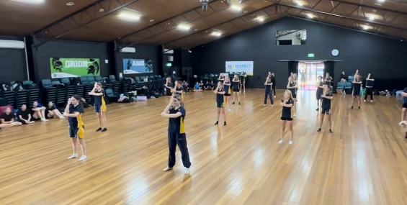**BISHS CREST: Dance Program 2025**

**Expression of Interest**

Your student is invited to Express their interest for the BISHS CREST: Dance Program.

**What is the CREST Dance Program?**

Students in this program will:

* Learn and perform choreography across a range of Dance genres
* Create and perform choreography across a range of Dance genres
* Advance audience etiquette skills through participation at competitions and classroom showcases
* Explore artistic works from First Nations Artists and artists from other cultures
* Expand interpersonal and leadership skills through teaching original choreography to classmates

Students will be provided with the opportunity to perform in multiple eisteddfods throughout the year, school assembly performances and whole school productions. Bribie Island State High School Dance Program participants will also have opportunities to engage with external professionals to expand and develop their Dance skills and abilities.

Bribie Island State High School is looking for students who are passionate, innovative, motivated, respectful and resourceful. We are looking for students with a variety of skills including the ability to work as a team, trust and listen to others. While many have performing experience, we recognise that some students may not have had access to performance opportunities and we are keen to identify students who have potential.

**Expectations**

We are seeking applicants who are interested in the area of Dance, and want to develop their skills over the 6 years that they are enrolled at Bribie Island State High School. Although the expectation is not that they choose this as a career, our Dance Program provides students with high-level skills that become invaluable in the real world.

**Students who are selected for the CREST: Dance Program will be committed to the course for a minimum of 1 year, unless the student does not meet the expectations outlined as above as determined by the school. Students will have the opportunity to re-apply for the Program each subsequent year**

**Selection Criteria**

Dance is not merely about performing. We are looking for a range of qualities including:

* Enthusiasm and motivation
* Commitment
* Willingness to learn
* A passion for Dance and the Performing Arts

**Personal Qualities**

* Ability to work effectively as part of a group
* Leadership qualities
* Motivation for wanting to be an active part of the program
* An effective and enthusiastic manner
* A willingness to accept unfamiliar tasks and challenges
* Aptitude and eagerness to learn and approach new material and concepts

**Our Dance Agreement**

In Dance, we commit to engaging with all activities, dances and requirements during rehearsals, events and excursions. We ensure that all members of the dance team are made to feel welcome and that all comments are positive. As a team, we support each other and encourage all members, teachers and visitors.

**Selection and Application for the Program**

* All students interested in applying for the CREST: Dance program for 2025 must submit an **Expression of Interest form** located on the school website by return emailing [jjjef0@eq.edu.au](mailto:jjjef0@eq.edu.au) by Term 4 Week 2- Tuesday the 8th of October 2024
* All Year 6 students applying for the program are required to register your interest also by the following link:

<https://forms.office.com/r/edNt3h8TfS>

For further information of enquiries, please contact Jayden Jeffery at jjjef0eq.edu.au or call Bribie Island State High School on 3400 2444.

Kind regards,

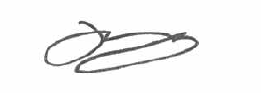

Mr Matthew Bradley Mr Jayden Jeffery

**Principal Head of Department- Junior Secondary**

|  |  |  |  |  |  |
| --- | --- | --- | --- | --- | --- |
| **BISHS CREST DANCE- EXPRESSION OF INTEREST FORM** | | | |  | |
|  |  | **STUDENT DETAILS** | |  | |
| STUDENT NAME |  |  | | | |
| DATE OF BIRTH |  |  | GENDER |  |  |
| ADDRESS |  |  | |  | |
| YEAR LEVEL APPLYING FOR IN 2025 (please circle) | Year 7 |  | Year 8 |  | Year 9 |
| PREVIOUS SCHOOL |  |  | |  | |

|  |  |  |  |
| --- | --- | --- | --- |
|  | **PARENT DETAILS** | | |
| PARENT 1 |  | PARENT 2 | |
| FULL NAME |  | FULL NAME |  |
| PHONE NUMBER |  | PHONE NUMBER |  |
| EMAIL |  | EMAIL |  |
| ADDRESS (if different from student) |  | ADDRESS (if different from student) |  |

**BISHS CREST DANCE- EXPRESSION OF INTEREST**

1. **Why would you like to be involved in the DANCE program at Bribie Island State High School?**

1. **Are you currently involved in your school dance community? If so, how are you involved?**
2. **How are you currently involved in the dance community outside of school? If so, how are you involved?**
3. **What is your current level of experience doing dance?**